**Amazon Simple Notification Service (Amazon SNS)**

**Amazon Simple Notification Service (Amazon SNS)**is a publish/subscribe service. Using Amazon SNS topics, a publisher publishes messages to subscribers. This is similar to the coffee shop; the cashier provides coffee orders to the barista who makes the drinks.

In Amazon SNS, subscribers can be web servers, email addresses, AWS Lambda functions, or several other options.

**Serverless computing**

Earlier in this module, you learned about Amazon EC2, a service that lets you run virtual servers in the cloud. If you have applications that you want to run in Amazon EC2, you must do the following:

* Provision instances (virtual servers).
* Upload your code.

🡪Continue to manage the instances while your application is running.

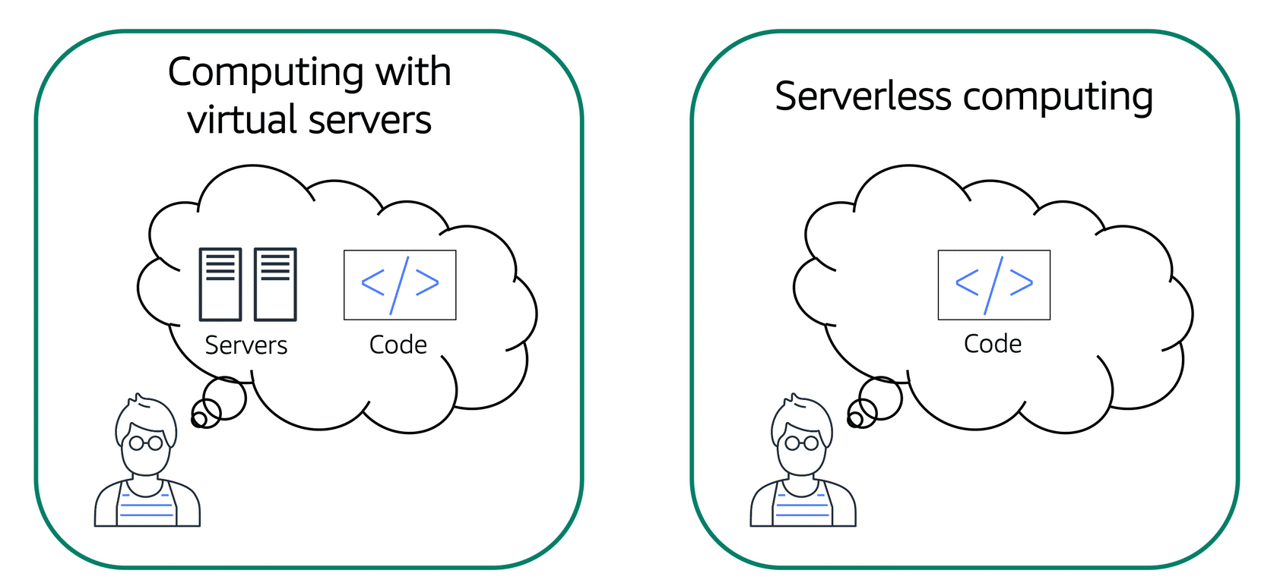

The term “serverless” means that your code runs on servers, but you do not need to provision or manage these servers. With serverless computing, you can focus more on innovating new products and features instead of maintaining servers.

Another benefit of serverless computing is the flexibility to scale serverless applications automatically. Serverless computing can adjust the applications' capacity by modifying the units of consumptions, such as throughput and memory.

An AWS service for serverless computing is **AWS Lambda**.

**AWS Lambda**

[**AWS Lambda**](https://aws.amazon.com/lambda) is a service that lets you run code without needing to provision or manage servers.

While using AWS Lambda, you pay only for the compute time that you consume. Charges apply only when your code is running. You can also run code for virtually any type of application or backend service, all with zero administration.

For example, a simple Lambda function might involve automatically resizing uploaded images to the AWS Cloud. In this case, the function triggers when uploading a new image.

**Amazon Elastic Container Service (Amazon ECS)**

[**Amazon Elastic Container Service (Amazon ECS)**](https://aws.amazon.com/ecs/) is a highly scalable, high-performance container management system that enables you to run and scale containerized applications on AWS.

Amazon ECS supports Docker containers. [Docker](https://www.docker.com/) is a software platform that enables you to build, test, and deploy applications quickly. AWS supports the use of open-source Docker Community Edition and subscription-based Docker Enterprise Edition. With Amazon ECS, you can use API calls to launch and stop Docker-enabled applications.

**Amazon Elastic Kubernetes Service (Amazon EKS)**

[**Amazon Elastic Kubernetes Service (Amazon EKS)**](https://aws.amazon.com/eks/)is a fully managed service that you can use to run Kubernetes on AWS.

[Kubernetes](https://kubernetes.io/) is open-source software that enables you to deploy and manage containerized applications at scale. A large community of volunteers maintains Kubernetes, and AWS actively works together with the Kubernetes community. As new features and functionalities release for Kubernetes applications, you can easily apply these updates to your applications managed by Amazon EKS.

**AWS Fargate**

[**AWS Fargate**](https://aws.amazon.com/fargate/)is a serverless compute engine for containers. It works with both Amazon ECS and Amazon EKS.

When using AWS Fargate, you do not need to provision or manage servers. AWS Fargate manages your server infrastructure for you. You can focus more on innovating and developing your applications, and you pay only for the resources that are required to run your containers.

**`**

**3.GLOBAL INFRA &RELIABILITY..**

**AWS global infrastructure**

 four key factors to choose a Region:

* Compliance,
* proximity,
* feature availability,
* and pricing.

**Availability Zones**

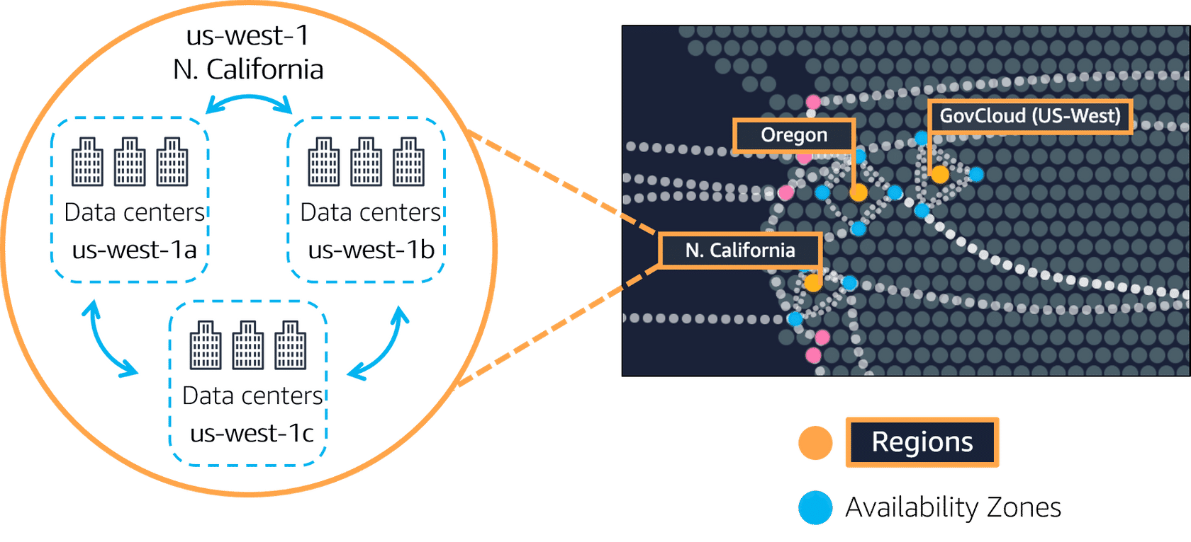

An **Availability Zone** is a single data center or a group of data centers within a Region. Availability Zones are located tens of miles apart from each other. This is close enough to have low latency (the time between when content requested and received) between Availability Zones. However, if a disaster occurs in one part of the Region, they are distant enough to reduce the chance that multiple Availability Zones are affected.

So here's the key points. Number one,

Regions are **1.geographically isolated areas,**

where you can access services needed to run your enterprise.

**2.Regions contain Availability Zones,**

that allow you to run across physically separated buildings, tens of miles of separation, while keeping your application logically unified. Availability Zones help you solve high availability and disaster recovery scenarios, without any additional effort on your part,

**3.AWS Edge locations run Amazon**

CloudFront to help get content closer to your customers, no matter where they are in the world.

**Edge locations**

An **edge location** is a site that Amazon CloudFront uses to store cached copies of your content closer to your customers for faster delivery.

# How to provision AWS resources:

For example, you can launch an EC2 instance or you can create an AWS Lambda function. Each of those would be different requests and different API calls to AWS. You can use the

**Ways to interact with AWS services**

**1.AWS Management Console,**

**2.the AWS Command Line Interface,**

**3.the AWS Software Development Kits,**

or various other tools like AWS CloudFormation, to create requests to send to AWS APIs to create and manage AWS resources.

**AWS Elastic Beanstalk**

With **AWS Elastic Beanstalk**, you provide code and configuration settings, and Elastic Beanstalk deploys the resources necessary to perform the following tasks:

* Adjust capacity
* Load balancing
* Automatic scaling
* Application health monitoring

**AWS CloudFormation**

With **AWS CloudFormation**, you can treat your infrastructure as code. This means that you can build an environment by writing lines of code instead of using the AWS Management Console to individually provision resources.

AWS CloudFormation provisions your resources in a safe, repeatable manner, enabling you to frequently build your infrastructure and applications without having to perform manual actions. It determines the right operations to perform when managing your stack and rolls back changes automatically if it detects errors.

**Amazon Virtual Private Cloud (Amazon VPC)**

Imagine the millions of customers who use AWS services. Also, imagine the millions of resources that these customers have created, such as Amazon EC2 instances. Without boundaries around all of these resources, network traffic would be able to flow between them unrestricted.

A networking service that you can use to establish boundaries around your AWS resources is [**Amazon Virtual Private Cloud (Amazon VPC)**](https://aws.amazon.com/vpc/).